Kalden varden
St10476957
WEDE Project Proposal 1

Contents
Proposal 1 - Greenleaf Café 2
Project Title 2
Mission & Vision Statement 2
Project Goals 2
Target Audience 3
Background of the Organization 3
Content Needs 4
Design Ideas & Inspiration 4
Proposal research 5
1. Xpresso Café (xpressocafe.co.za) 5
2. Santosa Coffee (santosacoffee.co.za) 5
3. Boston Brew Cafe (bostonbrewcoffee.com – Durban) 6
SITE MAP 7
Wire frame 8
Web site screen shots 10
GitHub LINK 13
Bibliography References 14
Code Attribution 14

Proposal 1 - Greenleaf Café

Project Title
“Greenleaf Café – Sustainable Coffee Experience Website”

Mission & Vision Statement
Mission: Greenleaf Café is committed to serving exceptional, ethically sourced coffee and wholesome meals while fostering environmental sustainability and strengthening community connections. We aim to educate our customers about sustainable living through both our products and our practices.

Vision: To become the most trusted and well-loved eco-friendly café in the city, recognised not only for great coffee but also for our leadership in sustainable practices, community engagement, and environmental advocacy. Brown, (2022)

Project Goals
Build brand awareness by designing a visually appealing and easy-to-navigate website that reflects the café’s eco-friendly values.
Increase sales by at least 15% within six months through the integration of an online ordering and takeaway system.
Improve customer engagement by posting bi-weekly blog content focusing on sustainability, coffee brewing techniques, and community events.
Showcase eco-initiatives such as zero-waste policies, composting practices, and
Fairtrade sourcing to position the café as a leader in sustainable hospitality. Brown, (2022)

Target Audience
Primary Audience: Environmentally conscious coffee enthusiasts aged 20–45 who value ethical consumption and sustainability.
Secondary Audience: Urban professionals seeking convenience and premium quality coffee.
Tertiary Audience: Local community members who attend events or participate in sustainability workshops. Brown, (2022)

Background of the Organization
Greenleaf Café was founded in 2018 by a group of friends passionate about coffee and sustainability. Located in the heart of Durban’s bustling city center, the café sources all coffee beans from Fairtrade-certified farms and implements a strict zero-waste policy. The business has grown steadily, developing a loyal base of repeat customers. However, its online presence is limited to a basic social media profile, and the lack of a dedicated website has restricted its ability to attract new customers, promote online orders, and expand awareness of its eco-friendly initiatives. Unsplash (2025)

Content Needs
Homepage: Eye-catching hero image of the café, a brief welcome message, and a clear call-to-action for ordering online.
Menu Page: Interactive menu with item descriptions, prices, and allergen information.
Sustainability Page: Detailed description of sourcing methods, partnerships with Fairtrade farms, and waste reduction processes.
Blog Section: Regular posts featuring eco-living tips, seasonal coffee specials, and coverage of community events.
Contact Page: Physical location, opening hours, Google Maps integration, and direct contact form.

All written content will be created in-house to maintain authenticity, and imagery will be a combination of professional photos and royalty-free images from reputable sources such as Unsplashed. Brown, (2022)

Design Ideas & Inspiration
The website will adopt a minimalist, nature-inspired design with a colour palette of earthy greens, browns, and cream tones. The layout will be uncluttered, featuring large visuals, simple typography, and intuitive navigation. The user interface will be optimized for both desktop and mobile users. Unsplash (2025)

Proposal research

1. Xpresso Café (xpressocafe.co.za)
Why it works:
- Keeps things simple - their unique selling point is “everything is one price.”
- The website reflects that with a clean, no-clutter layout: visitors immediately see the concept (R14 menu).
- Focuses on speed and clarity, since customers are usually takeaway driven.
How it works (layout & flow):
- Homepage: Hero banner + flat-pricing info.
- Menu section: Grid/list style showing items (coffee, pastries, etc.). • Franchise page: Clear CTA for “Join us / Franchise opportunities.”
- Contact info: Standard footer with phone/email + social media.
- Navigation: Linear, few menu items - users can find what they need in 1–2 clicks.

2. Santosa Coffee (santosacoffee.co.za)
Why it works:
- Appeals to atmosphere lovers (students, creatives, locals).
- The site is designed to feel like the café itself: warm colors, cozy layout, bohemian vibe.
- The website is not just selling coffee; it’s selling an experience.
How it works (layout & flow):
- Homepage: Hero section with café images → sets mood immediately.
- About page: Storytelling layout (who they are, philosophy).
- Menu page: Visual, segmented by categories (coffee, food, mocktails).
- Venue hire page: Details + booking form.
- Gallery page: Visual-heavy lifestyle photos.
- Contact page: Info + Google map.

3. Boston Brew Cafe (bostonbrewcoffee.com – Durban)
Why it works:
- Targets specialty coffee lovers → people who care about quality, origin, story.
- Website design is minimalist but premium (clean fonts, white space, big images).
- Build trust by highlighting roastery partnerships and artisanal feel.
How it works (layout & flow):
- Homepage: Hero image with tagline → sets a “craft coffee” mood.
- About page: Story of the café → heritage house location, Boston Terrier theme.
- Menu page: Simple list/grid of drinks + food.
- Merch/shop page (if enabled): Buy beans, merch, or cold brew.
- Contact page: Info + Google Map + hours.
General Layout Pattern Across All 3 Almost all café websites follow this design:
- Hero Section - big image + tagline + CTA.
- About Section - mission, story, or unique concept.
- Menu Section - drinks & food.
- Services/Extras - online orders, catering, workshops.
- Community/Blog/Gallery - lifestyle appeal.
- Contact Info - map, hours, form.
- Footer - socials, copyright, quick links.

SITE MAP
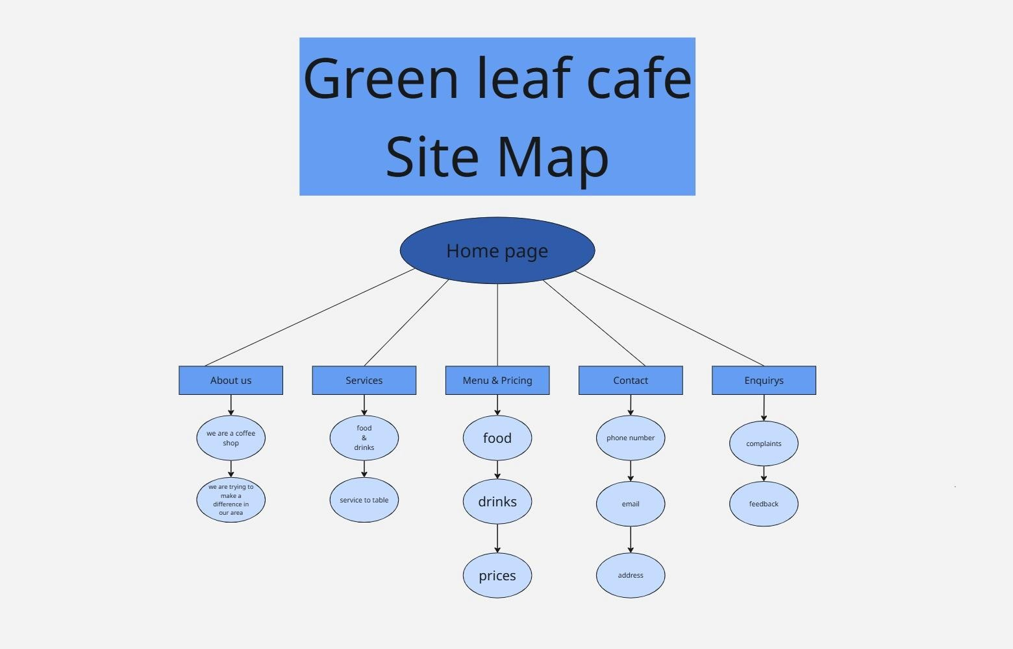
Miro, n.d. Miro. Available at: https://miro.com/ [Accessed 25 August 2025].

Wire frame

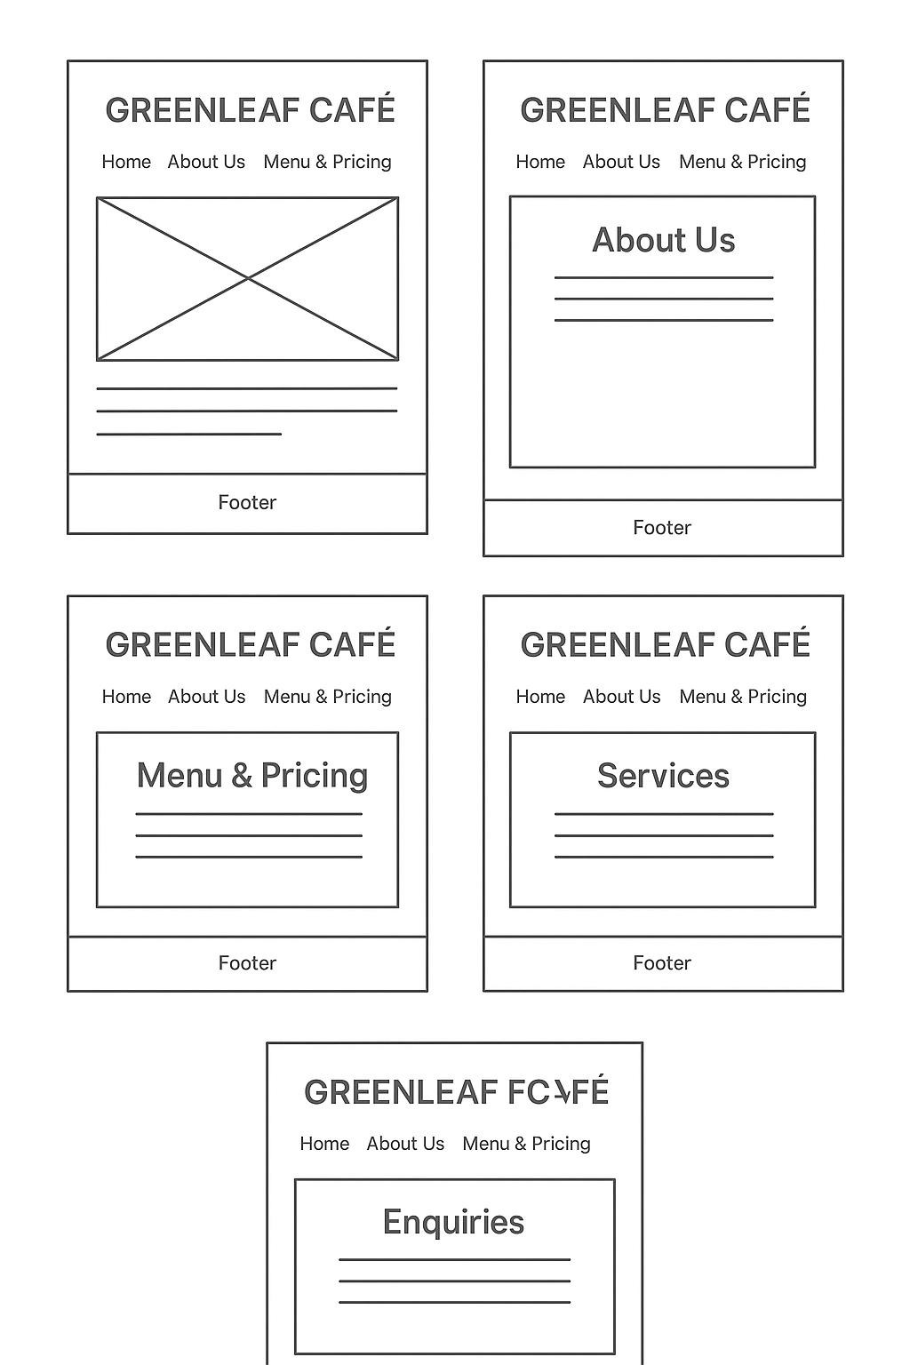

Web site screen shots
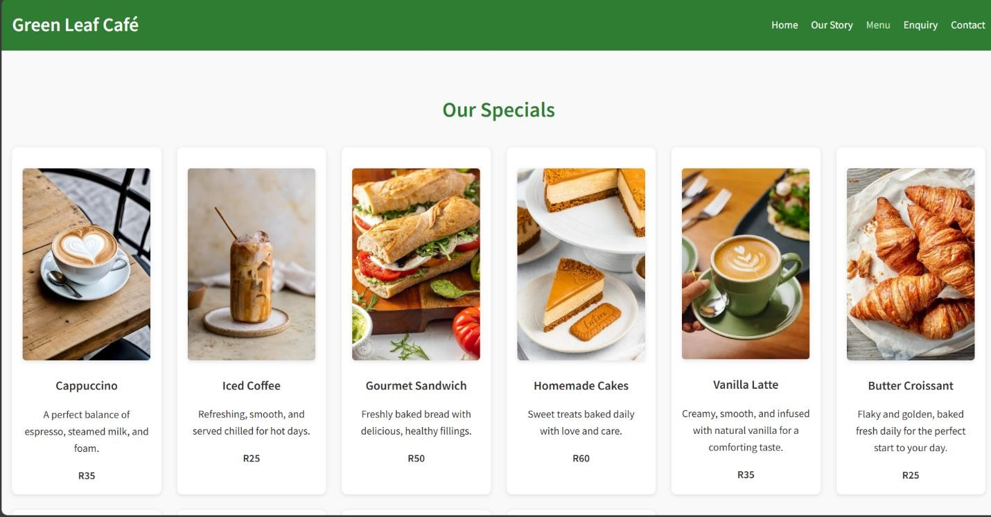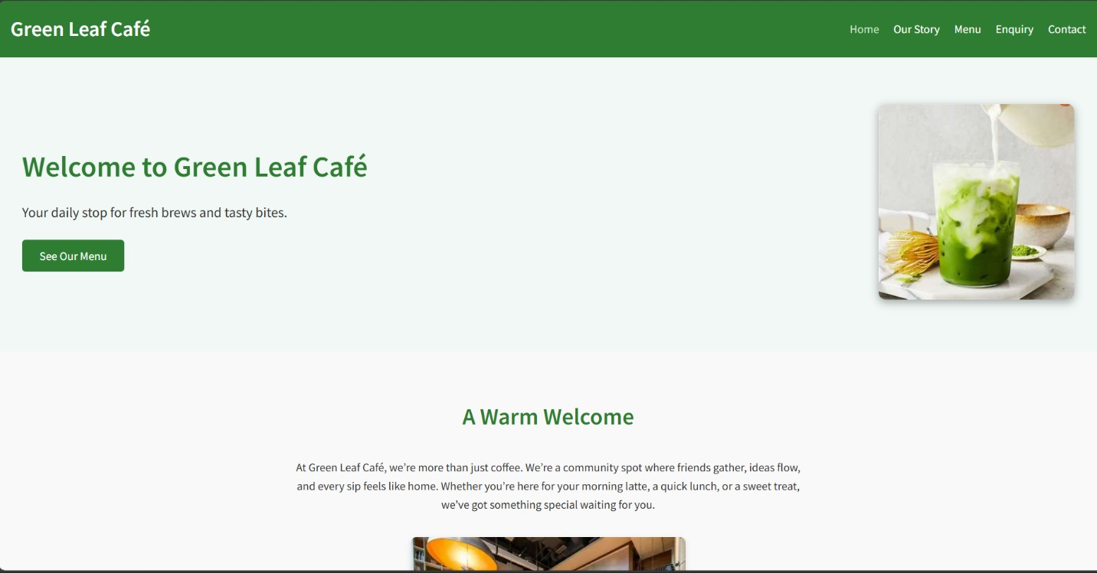

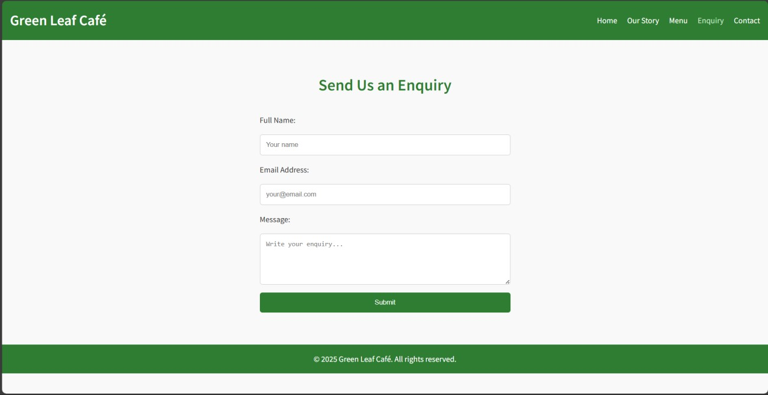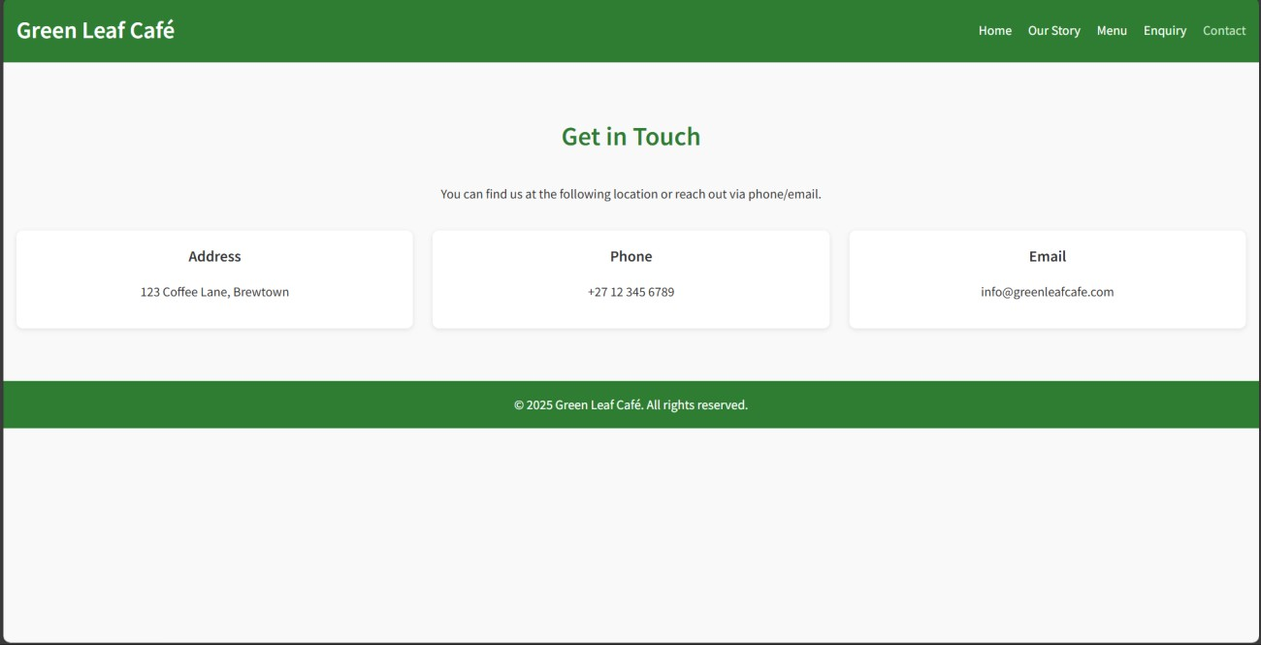
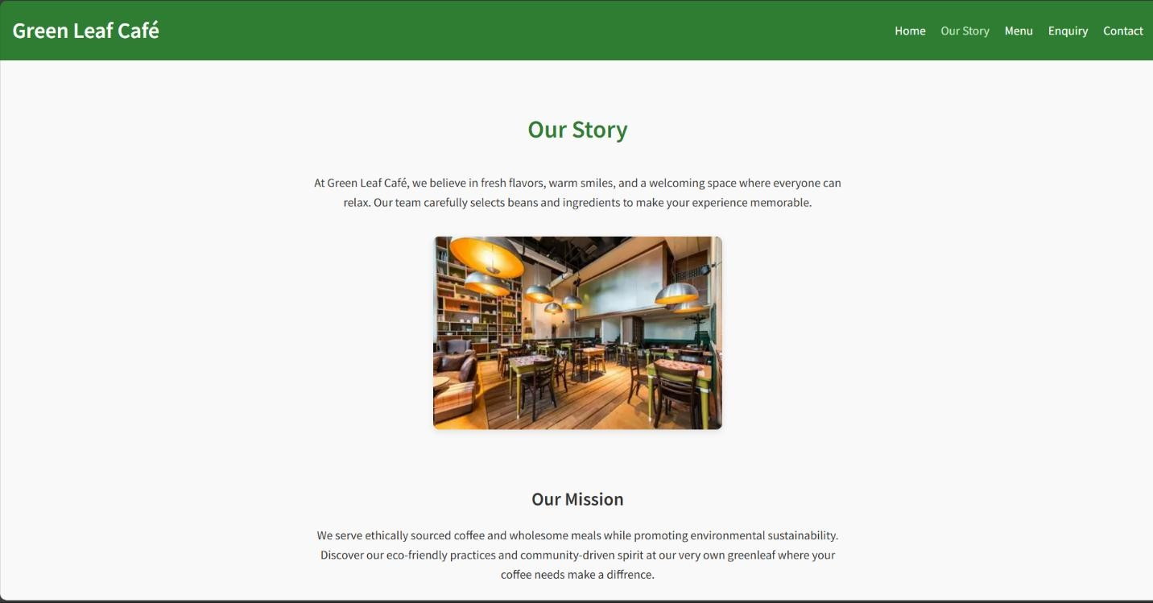

GitHub LINK
Part 1 github link https://github.com/VCDN-2025/wede5020-part-1-st10476957.git
Part 2 github link https://github.com/st10476957/Wede-poe-part2.git
Part 3 github link https://github.com/st10476957/Wede-poe-part-3.git

Bibliography References
Unsplash, 2025. Free coffee shop images. Available at: https://unsplash.com/s/photos/coffee-shop [Accessed 24 August 2025].
Brown, L., 2022. Sustainable branding strategies. Journal of Green Marketing, 15(3), pp.45–59.
Xpresso Café, 2025. Xpresso – Affordable freshly brewed coffee. Available at: https://xpressocafe.co.za/ [Accessed 24 August 2025].
Santosa Coffee, 2025. Santosa Coffee Shop. Available at: https://www.santosacoffee.co.za/ [Accessed 24 August 2025].
Boston Brew Coffee, 2025. Coffee Shop Boston Brew café Berea. Available at:
https://www.bostonbrewcoffee.com/ [Accessed 24 August 2025].
Miro, n.d. Miro. Available at: https://miro.com/ [Accessed 25 August 2025].

Code Attribution
Code Attribution
Author: W3schools Title: HTML Tutorial date published: n.d
link/URL: https://www.w3schools.com/html/
Date accessed: 24/09/2025

Code Attribution
Author: W3schools
Title: CSS Tutorial date published: n.d
link/URL: https://www.w3schools.com/Css/
Date accessed: 24/09/2025

Code Attribution
Author: W3Schools
Title: JavaScript Form Validation Tutorial
Date Published: n.d.
Link/URL: https://www.w3schools.com/js/js_validation.asp
Date Accessed: 01/11/2025

Code Attribution
Author: W3Schools
Title: JavaScript HTML DOM Tutorial
Date Published: n.d.
Link/URL: https://www.w3schools.com/js/js_htmldom.asp
Date Accessed: 01/11/2025

